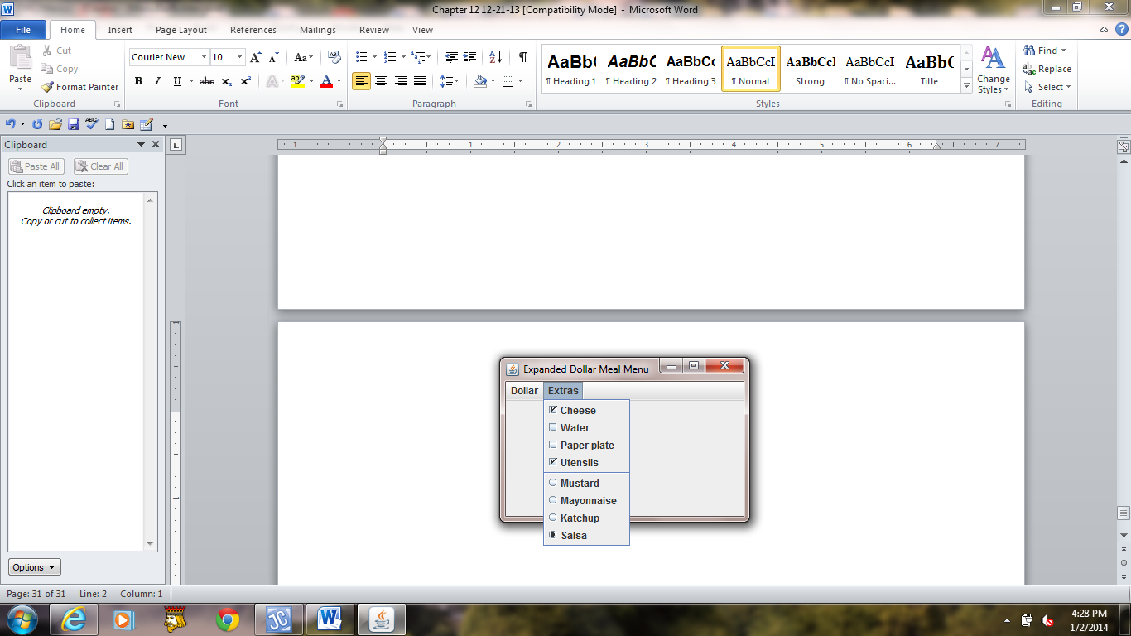

**Figure 12.16 A GUI menu built containing check boxes and radio buttons .**